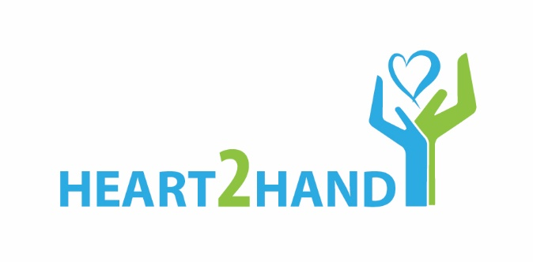
21 May 2018

Media Release

A #Heart2Hand helping hand for Maitland Cottage Children’s Orthopaedic Hospital

Children at the Maitland Cottage Children’s Orthopaedic Hospital in Newlands, Cape Town now have a brighter, more cheerful environment to rest and recuperate, after corporates and volunteers joined forces with NPO, Blue Sky Society Trust (BSST), for Project #Heart2Hand.
There were heart-warming scenes at the facility this morning when the new R80 000 upgrade was unveiled. Spearheaded by BSST, The Lion Match Company's subsidiary company NSP Unsgaard and their brand Cherubs , and The Little Optimist Trust, Project #Heart2Hand was a month-long undertaking that gave parts of the hospital a makeover.
As one of just two Paediatric Orthopaedic Hospitals in the Southern Hemisphere, Maitland Cottage Children’s Hospital performs hundreds of life-changing operations each year. The little patients range in age from birth to 15 years and they are treated for all forms of bone disease and disabilities. The hospital also treats children who are injured in motor vehicle accidents.

Certain areas within the hospital required some TLC so the #Heart2Hand team worked its magic, replacing flooring, providing new curtains and painting a happy, joyful mural on an outside wall to create a positive surrounding that serves as an instant “pick-me-up” thereby assisting with recovery and recuperation.

“It is truly humbling and inspiring to see such phenomenal results when a group of individuals and corporates work together, combining compassion and resources,” says Carla Geyser, founder of Blue Sky Society Trust. “Cherubs has made it possible for us to give a sick child hope in terms of a happy environment to rest and recover, and this is incredibly rewarding and inspiring. I firmly believe that we have all made a small, though impactful, difference for these little ones.”

It is this opportunity to help elicit positive transformation that spurred Cherubs into making a significant contribution to #Heart2Hand as part of its CSI project. “NSP Unsgaard, a subsidiary of The Lion Match Company, is honoured to be part of this project and to be able to contribute towards uplifting the daily morale and happiness of the children at Maitland Cottage Children’s Orthopaedic Hospital in Newlands,” says George Lemon, General Works Manager at NSP Unsgaard. “The feedback from our staff was that it was an eye-opener to experience the joy of something so small and that they in turn came away enriched from this humbling experience. We are delighted to hear that the mural on the wall has impacted the children in a positive way and hope that this small contribution from the NSP Unsgaard team can go a long way to improving the children’s wellbeing while they are in hospital. A positive and happy environment will most definitely play a significant role in a speedy and less stressful recovery process of these children.”

“The Lion Match Company are truly grateful to be involved with the #Heart2Hand project with our subsidiary Company, NSP Unsgaard and Cherubs brand,” explains Milena Domiro, CSI Manager. “Part of growing our company ethos and awareness, we strongly believe in giving back to the communities who are so loyal to our brand and in doing so we get a chance to make a difference and change a child’s life.”

All the wards in the Maitland Cottage Children’s Hospital have an entire wall made up of glass windows which serves to “bring the outside in”. While this gives the children a bright, airy view of the sky, the mountain and trees, it also presented the challenge of too much sunlight or cold entering the wards. Project #Heart2Hand provided 32 drops of quality, thick yet breathable, curtaining to keep the wards cool in summer and snug and warm in winter. The curtains are almost ready and the girls’ ward and the pre and post-operative wards will be kitted out over the next few days.

When concern was raised that the state of the floor in the boy’s ward was not conducive to daily wear especially when little ones were being wheeled to the X-ray department or to the operating theatre, or when children were using walking aids, Polyflor and Teck Flooring jumped at the chance to help make a difference. They resurfaced and screeded the floor, giving it a complete upgrade.

In addition to helping spruce up the wards, Project #Heart2Hand has gifted 200 copies of Greg Bertish’s book, The Little Optimist, to the hospital. Bertish, who played an integral role in the upgrade, says the initiative was all about passion and belief. “The Little Optimist Trust is proud to be the catalyst to do good and bring these amazing sponsors, volunteers and this project together. The new floors, curtains and the beautiful Little Optimist mural and books, will help to inspire these kids to get better quicker and go out and follow their dreams!"

Scenes from The Little Optimist have been lovingly painted on the wall outside the boys’ ward. A total of 37 metres of wall was cleaned and painted since the start of Project #Heart2Hand, thanks to Dekro Paints. Within weeks, the structure went from forlorn to fabulous as staff and volunteers from Cherubs and the hospital helped artist Chip Snaddon weave magic with paintbrushes.

“Our heartfelt thanks goes out to all who made this possible, all for the comfort and delight of our Little patients,” says Julie Scott, Chair of the Maitland Cottage Children’s Orthopaedic Hospital.
“We have been overwhelmed by the generosity, commitment and energy that has been invested in our hospital. The spirit of giving has been so tangible and the momentum has been incredible. Our children will get so much joy out of the beautiful mural and a lot more comfort from the new flooring.”

BSST’s Carla Geyser echoes this sentiment. “If we can help make their stay in hospital comfortable and perhaps all the more bearable by bringing about impactful, positive change, then our #Heart2Hand team would have achieved what we had set out to do.”

For more information on Blue Sky Society Trust’s Project #Heart2Hand, visit https://www.blueskysociety.org/
For interview opportunities, kindly contact anisa@kznmc.co.za

Images: Provided
Captions:

1: Before Project #Heart2Hand team members picked up their paintbrushes, this is what the wall outside the boys’ ward at Maitland Cottage Children’s Hospital looked like.
2: Hard at work, the #Project Heart2Hand team in the midst of their makeover
3: After the hard work: The wall has been transformed into a scene from Greg Bertish’s inspiring book, The Little Optimist. Now children in the boys’ ward will look out at the cheerful scene.
4: The #Heart2Hand team that made it all happen at Maitland Cottage Children’s Hospital (from left): Nicole Viveiros (Cherubs), Carla Geyser (Blue Sky Society Trust), Hayleen Du Preez (Cherubs), and George Lemon (Lion Match Group).
5 & 6: Project #Heart2Hand delivered an R80 000 upgrade to Maitland Cottage Children’s Hospital that included new flooring, new curtaining, new painting and 200 copies of Greg Bertish’s book, The Little Optimist, being donated to the little patients.
7: Author, Greg Bertish and illustrator, Chip Snaddon at this morning’s Project #Heart2Hand handover at Maitland Cottage Children’s Hospital.

ENDS

Issued on behalf of Blue Sky Society Trust by KZN Media and Communications
Email: anisa@kznmc.co.za
Mobile: 072 175 6350
Website: www.kznmc.co.za
Twitter: @anisaussuph

